UNIVERSITY OF PADOVA
ENROLLMENT PROCEDURE
PhD COURSES
39th SERIES - A.Y. 2023/2024

The enrollment procedure at the PhD courses at the University of Padova is organized in three phases:

- Registration in the University online system UNIWEB
- Completing the online enrollment form and upload attachments
- Registration fee payment

The online procedure is open from 11 September 2023 to 13 September 2023 at 13.00 (CEST)

1° Phase: Registration in the University online system UNIWEB

- From the website http://www.unipd.it/ log into Uniweb services (top left menu) according to the given instructions

- From the menu on top right side:
a) click on Login (if you have been previously enrolled at the University of Padova)
b) click on Registration (if you have never been previously enrolled at the University of Padova)
c) click on “Forgotten password” (if you don’t remember your username and password or if they have expired).

3. Once you have logged in click on ‘Home’ from menu on top right side.

4. In the section Master data you must check or update your personal data and contact details (residence and domicile addresses, email, phone numbers), and check the authorizations on the communications of your personal data.
You should then fill in the data of your bank account by clicking on ‘Home’ – ‘Master data’ – ‘Edit bank account refund data’. From the dropdown menu click on ‘Rimborso Bonifico Bancario’ and fill in the data requested. The student must be the account owner.
If you do not have a bank account yet, these data must be filled in by 5 October 2023. If you do not meet the aforementioned deadline, there may be problems in the payment of the PhD scholarship.

2° Phase: Completing the online enrollment form and upload attachments

- Click on ‘Home’ ‘Enrolment’ ‘Enrolment’ ‘Enrolment’ “Standard” and then on ‘Enrolment in unlimited-place degree courses’ and finally on ‘PhD courses’.

- Choose the course you want to enroll in and follow the procedure.

- Fill in with the data of your ID document and upload a .pdf file containing the picture of the same document you used to complete this procedure.

- Upload a color passport-size photo, where your face is clearly visible, preferably 35mm wide and 40 mm high (40 Megabytes max, saved as .jpeg or .jpg format), if not already uploaded.

- Check or fill in the data of your entry qualification (both if it has already been awarded or if it is still to be awarded – by 30 September 2023).

- Upload the documents related to the application duly filled in and signed and available on the webpage https://www.unipd.it/en/phd-programmes-calls-and-admissions:

- place acceptance form (1 .pdf file max weight 3MB)

- specific documentation of the place (maximum 4 .pdf files max weight 3MB). Here you can upload alternatively Form 1 for assignees with scholarships or Form 2 for winners of unfunded places.
In the case of joint attendance with Medical Specialization, Form 3 and the authorization of the Medical Specialization School and the Board of the PhD Course must also be uploaded here in accordance with the provisions of the Call.
Upload here Form 4 in case of scholarship funded by PNRR funds or MD 118/2023 funds.

- mandatory: for candidates with an academic qualification awarded abroad:
a) in case of academic qualifications awarded in non-EU Countries: a copy, in Italian or English, of the second-cycle degree (Master’s degree) as well as a copy of the certificate indicating the examinations taken and the relative grades, together with the translation, legalisation and Declaration of Value issued by Italian diplomatic or consular authorities or, alternatively, Statements of Comparability and Verification issued by ENIC-NARIC;
b) in case of academic qualifications awarded in European Union Countries: Diploma and Diploma Supplement in English for the second-cycle qualification (Master’s degree) or, alternatively, Statements of Comparability and Verification issued by ENIC-NARIC centres;

- mandatory: for candidates with a foreign academic qualification not yet awarded:
a) certificate or self-certification (in the cases provided for by Italian law) attesting the enrolment in a second cycle degree (Master’s degree);
b) certificate or self-certification (in the cases provided for by Italian law) of the list of exams/transcript of records of the second-cycle degree (Master’s degree), with grade;

- if available: a valid residence permit if already issued, or a copy of the receipt of the request made to the competent Authorities within 8 days from first arriving in Italy (only for non-EU citizens) (.pdf file max weight 3MB)

- The data of the first enrollment in the University system will appear. Check or specify the academic year.

If all the information is correct, the registration document can be viewed and printed by clicking on "Print registration application". The printout has the value of a personal summary; therefore, it is NOT necessary to go to the PhD Office.

If you want to delete or modify the online enrollment form click on ‘New enrollment’. The system will delete the old enrollment and accept the new one.

3° Phase: Registration fee payment

You will then have to pay the registration fee of € 200.00 through PagoPA following the instructions available on the page https://www.unipd.it/en/pagopa

Enrollment will be verified and finalized after the acquisition of the payment of the registration fee; the PhD office will make a telephone or e-mail contact only if the documentation is incomplete. We therefore recommend that you pay the fee as soon as possible.

Failure to submit the enrollment form and the relevant attachments by 13 September 2023 at 13.00 (CEST) and payment of the registration fee by 13 September 2023 at 23.59 (CEST), will be considered as firm withdrawal from the place/scholarship. Therefore, failure to meet the deadline will result in the loss of the entitlement to enroll in the specific Course and no justification will be accepted for the delay.

The following will not be accepted as proof of enrollment:
- only the payment of the contribution of euro 200,00
- only the online completing of the enrollment form

Ufficio Dottorato di ricerca
Sede: via Venezia 15 - Padova
Postal address: Ufficio Dottorato di ricerca, via 8 Febbraio, 2 - 35122 Padova,
e-mail: phd.application@unipd.it
Helpdesk ph. 049/8271827 from 10.00 to 12.30 CEST

STEP 1 - DATA REGISTRATION
Click on eng – English - on the top
Click on Registration and then Online registration
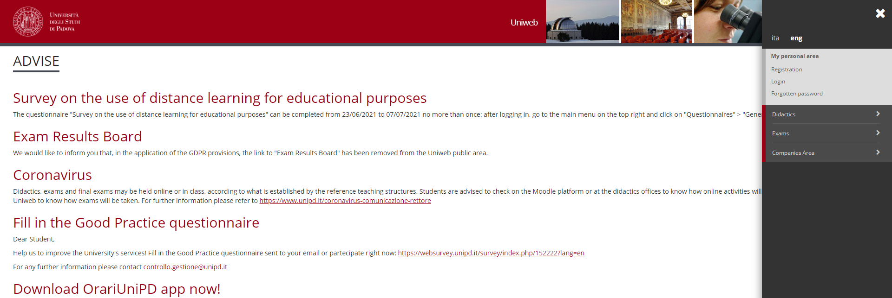
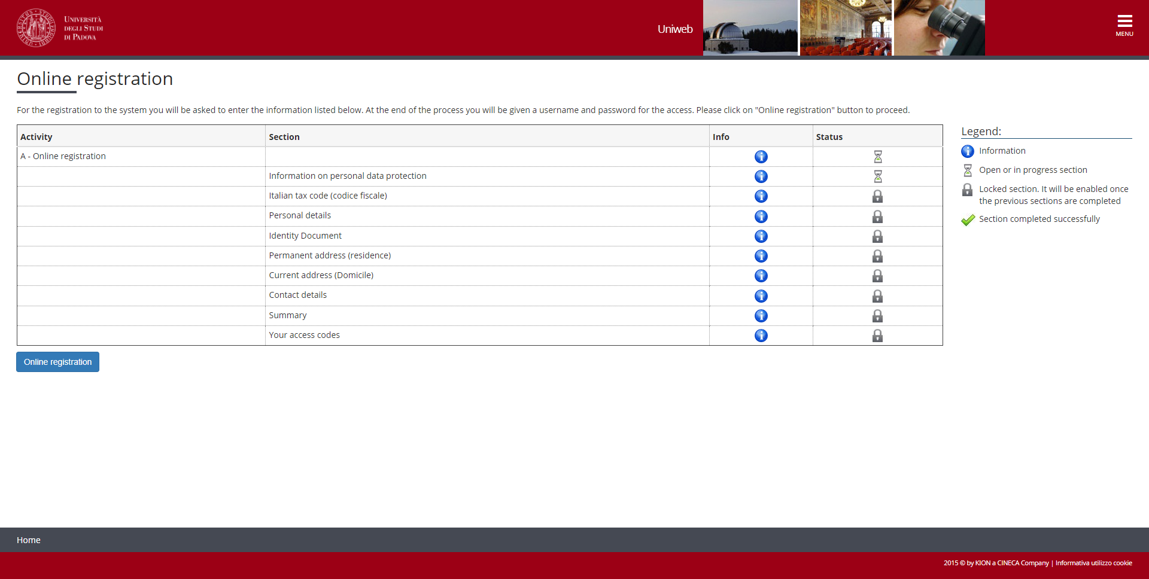
You will find the information on Data protection. After reading them, click on Forward at the end of the page

Then click on ‘I am a foreigner and do not have an Italian code’ and then on Next

Fill in your personal data. Please note that you need to put all your surnames and names in the same order as they appear in your Passport. Then click on Next
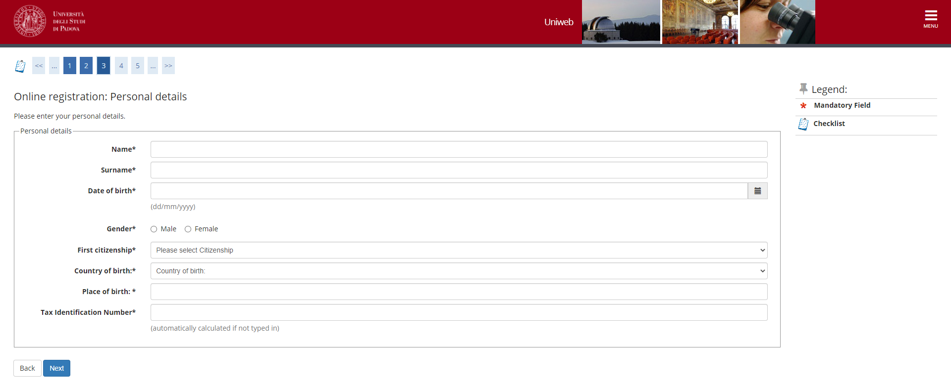

Fill the data of your Identity Document
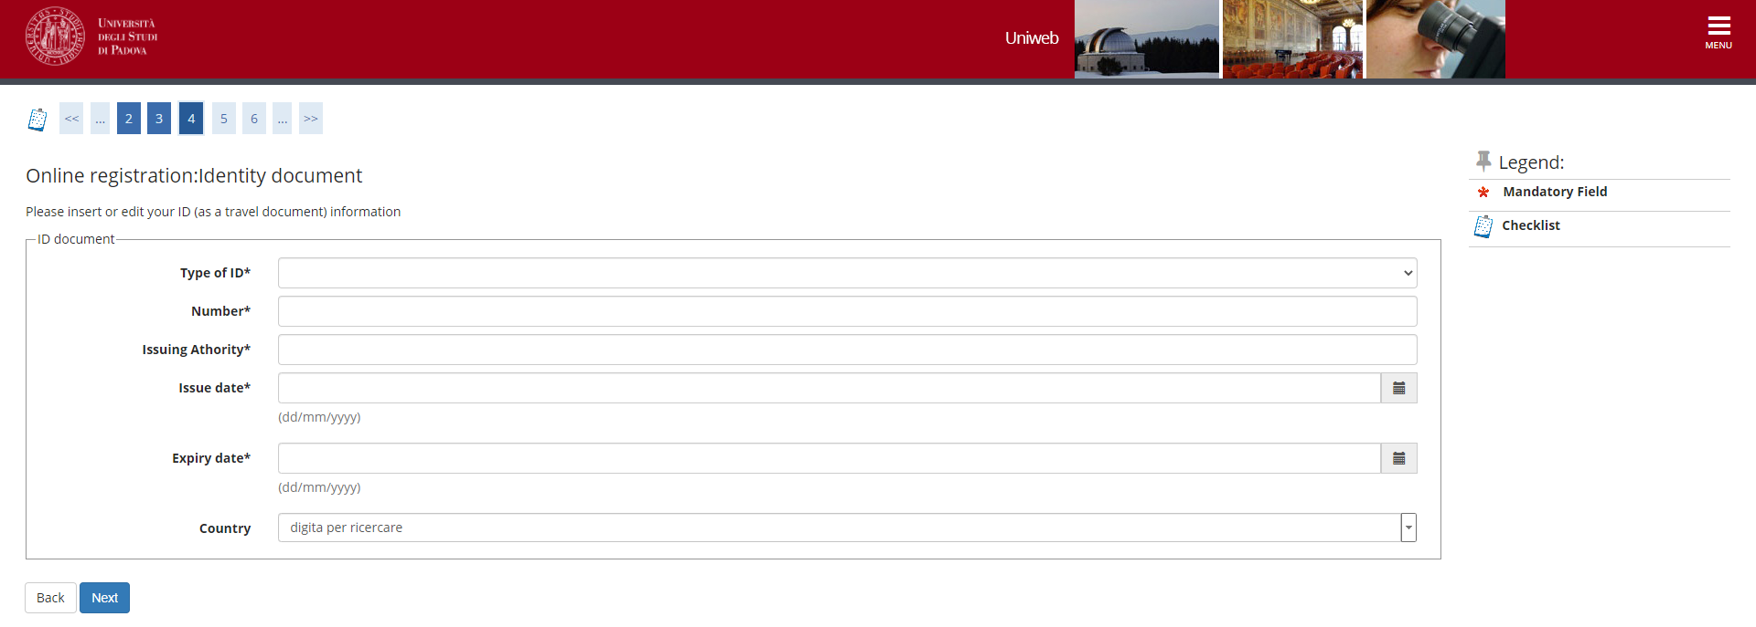

Then you will have to fill in the data concerning your residence and domicile and your contact details. At the end of the procedure, you are directed to a summary page, where you can edit the information provided if you want to correct any mistake or you can confirm the data by clicking on ‘Conferma’ at the end of the page

After clicking on ‘Conferma’ you will be directed to the page where you will find username and password. Then click on Leave page. You will also receive an email with the same username and password and the link to the First Activation page

You will be directed to the First Activation page (click on eng – English - on the top)
Type in first the username and in the following page the Activation code.
https://uniweb.unipd.it/password
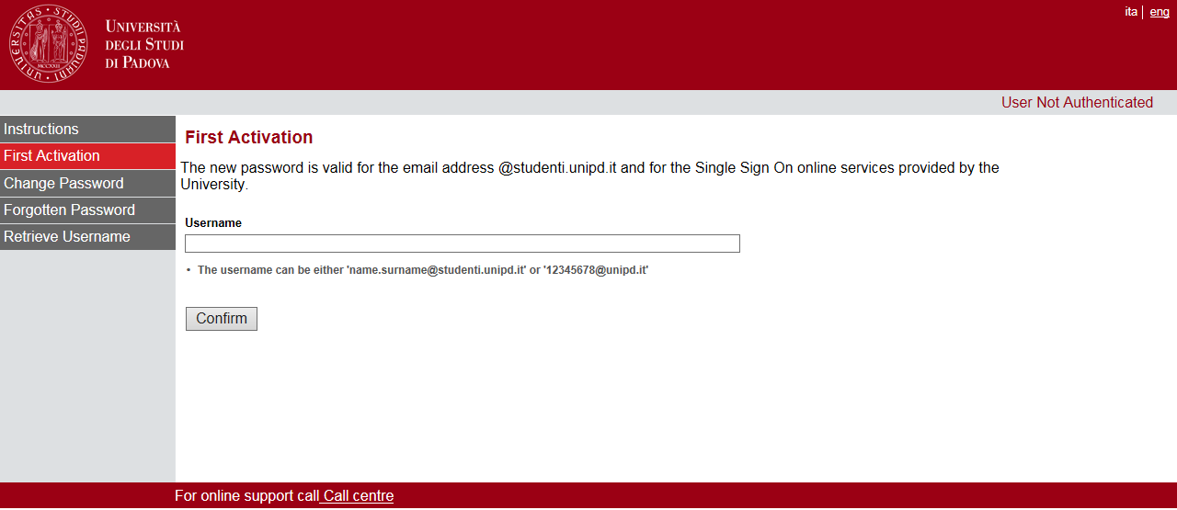
You will be directed to a page where you will have to choose three questions and related answer that will be asked to you in case you lose or forget the password.
At the end of the procedure click on Set password and you will direct to a page where you will choose your password.

STEP 2: LOG IN AND ENROLMENT
You can now go back to the homepage and Log in
https://uniweb.unipd.it/Home.do;jsessionid=6B297D055801F668C05866AD00F91271.jvm2c?cod_lingua=eng

Type in your username and password
Click on Home and then on Master data
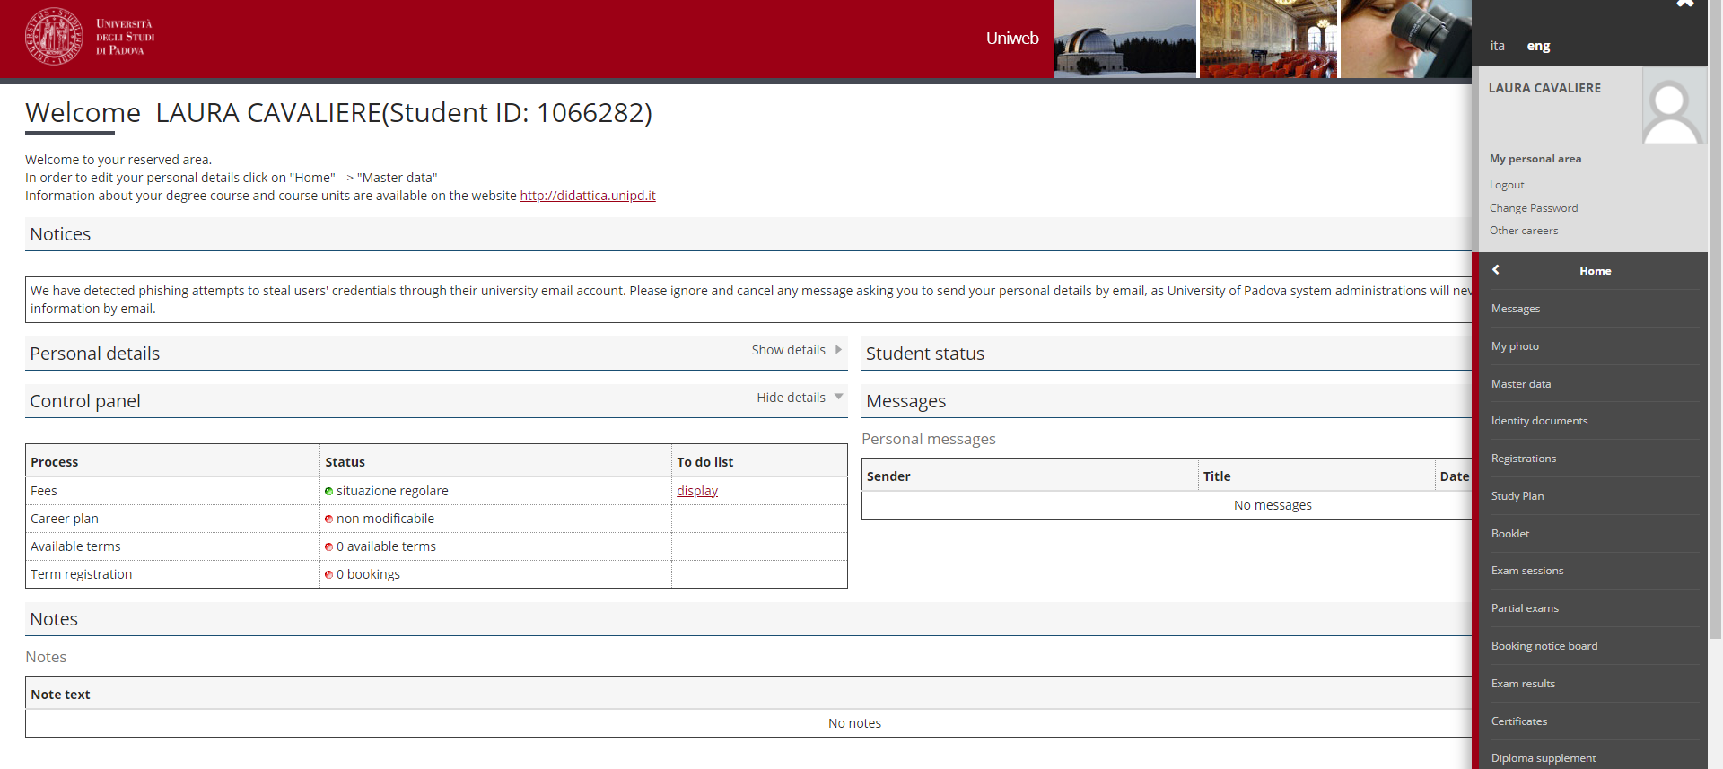

In the following page you can check and/or modify the personal data you specified in the Registration procedure by clicking on Edit. In particular you must click on Edit Contact details in order to give or deny the communication and/or the diffusion of your personal details. Then click on Edit Bank Account Refund data if you want to specify the data of the bank account for the payment of the fellowship . You can specify these data after you arrive in Italy and you open a bank account.

Now click on Enrolment in the left menu and then at the bottom of the page
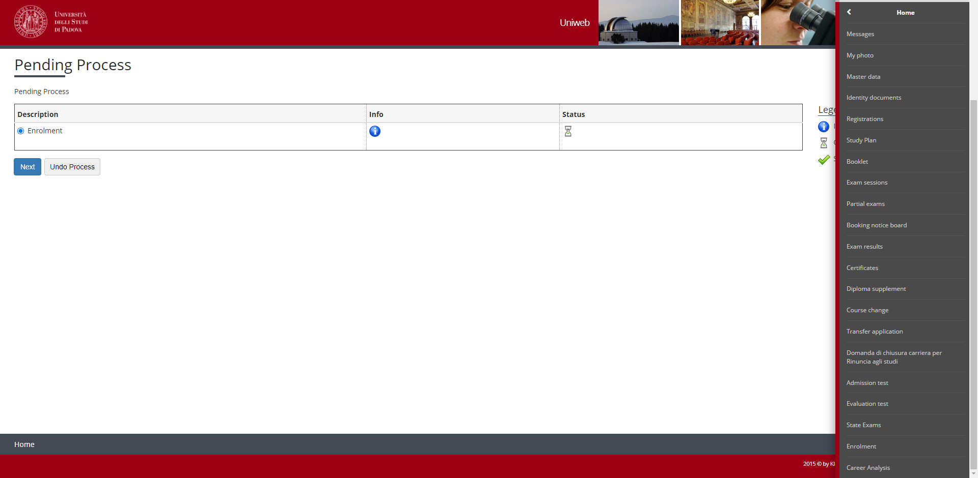
Click on Enrolment in unlimited-place degree courses and then on Next

Click on PhD Course

Choose the PhD course you want to enroll in and then on Next at the end of the page

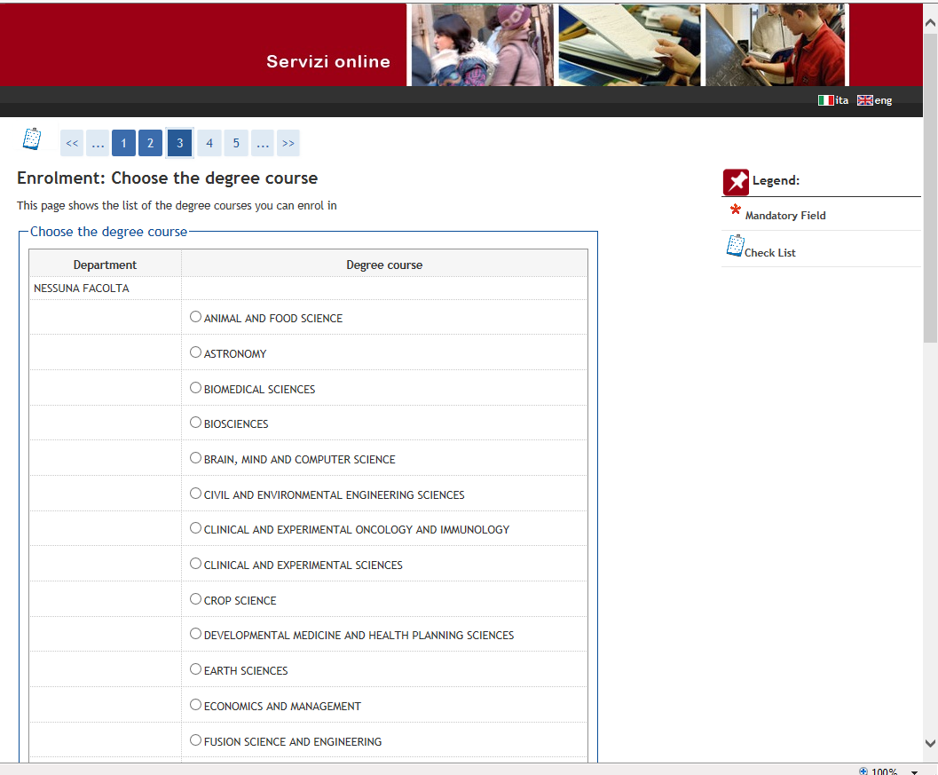

Confirm the data or go back if you want to change them
In the next page, you will see a list of types of qualification (the first three are Italian qualifications). You should see a green tick on the qualification you specified during the registration phase. In this case, you only need to click on Next at the end of the page. If you want, you can add other qualifications.

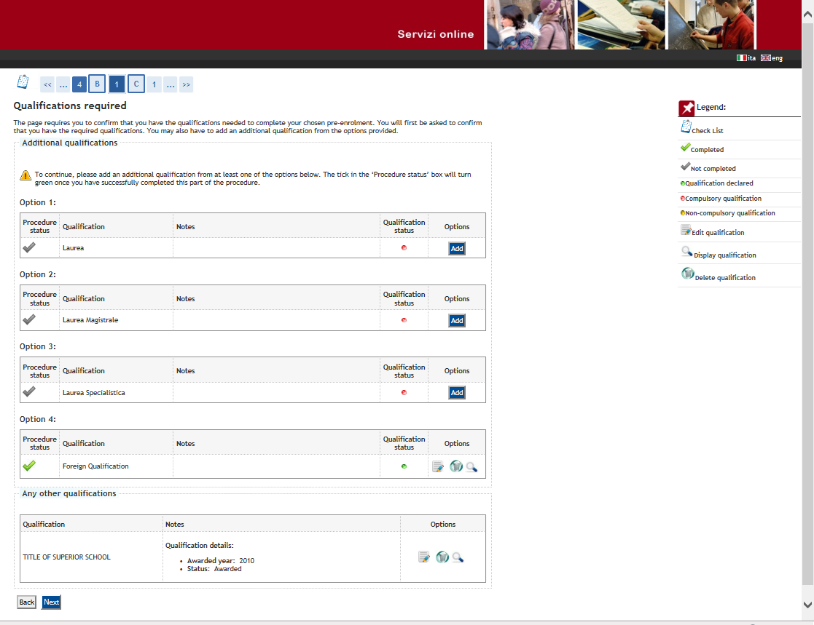

After clicking again on next you will be directed to that page where data on the first enrollment in the University System in Italy is provided (it means the first time you entered in an Italian University, even if it was not the University of Padova). You just need to verify or insert the academic year and click on ‘Avanti’

You will be directed to a summary page where you have to click on Confirm at the end of the page

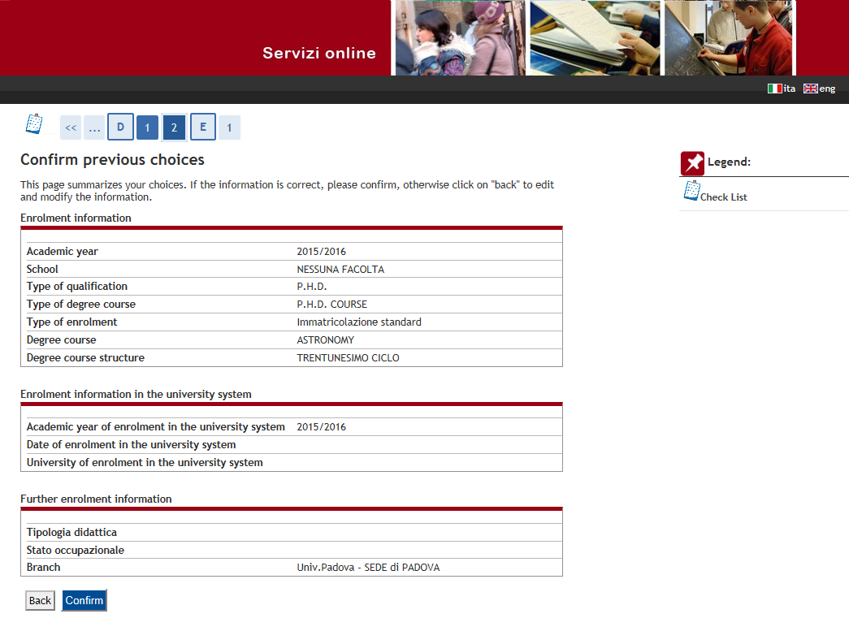
You will be directed to this page where you can print the enrollment form and the related documents or Proceed to a new enrollment.

